Business Strategy for Investors
Guide: 200 words
What’s your elevator pitch? How would you explain your business and the investment opportunity to a potential investor? This isn’t intended to be a lot of detail – it’s your hook although you could include a little more detail than the Vision section from your Pitch Deck. Your initial strategy section (which occurs before the table of contents) should be just enough to catch someone’s attention and draw them in. You want them hungry for more information.

Contents
Executive Summary 3
Company Overview 4
Market Position 5
Team 6
Milestones 7
Financials 8
5 Year Projections 8
Investment Strategy 8
Conclusions 9
Appendix A: 10 Year Projections 10
Appendix B: Optional 11

[After you finish adding all the content to your business plan, update the Table of Contents above so the sections and page numbers reflect your changes. Then delete this box.]

Executive Summary
Guide: 400 words
Describe the industry and the gap/ opportunity that exists. How does your business fit within the industry? In what way does your business address the gap/ opportunity? This is a great section to include statistics; be sure to include your references in the footnotes.
The information in this section should have strong ties to the content from the Pitch Deck in the Challenge and Solution sections. Investors should be able to understand what caused the challenge and why the solution makes sense.

[Add high-resolution image that
represents your business.]

Company Overview
Guide: 400 words
Tell me about your company. When was it founded and what does it do? Who are your target customers? Describe your products/ services and how they meet the needs of your customers. How have you been successful so far? What is it that makes your business amazing?

[Add high-resolution image that
represents your business.]

Market Position
Guide: 300 words
Describe the businesses that occupy this industry and the more specific market that you intend to compete in. How does yours compare? What makes your business different/ better?

[Key statistic or quote that supports your market position.]

Team
Guide: 300 words
Who are you? What do you and your leadership team bring in terms of experience and expertise? What are your roles in the company? How will you drive the business forward? Build from the information you included in the Pitch Deck.

Milestones
Guide: 200 words + visual
Where has your company been and where is it going? This information should expand on the initial milestones you included in the Pitch Deck. List recent years and high-level achievements. You should also include upcoming targets. The information needs to be laid out in a timeline. This section is more about helping your potential investor connect key data point in a visual format.

Financials

5 Year Projections
Guide: 200 words + 5-year financial projections
Describe your financial targets and how you plan to achieve them. What is the required investment and how are you going to spend it? Include a copy/paste of the Financial Projections template (years 1-5).

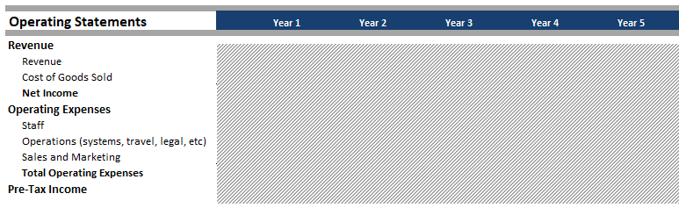

Investment Strategy
Guide: 200 words
If you are looking for a certain type or structure of investment, include a summary in this section.

Conclusions
Guide: 150 words
Summarize the investment that you are asking for. What is your final sales pitch to the potential investor to convince them not just to give you the money… but that they want – need – to give you the money. What can you say that will leave them wanting to call you immediately because they don’t want to miss out on investing in your business?
Contact:
[Name of Contact for Investors]
Email address
Phone number
[High-resolution company logo]

Appendix A: 10 Year Projections
Financial projections over the next ten years demonstrate the pattern of acquisitions, the operating expenses, and the resulting cash flow.
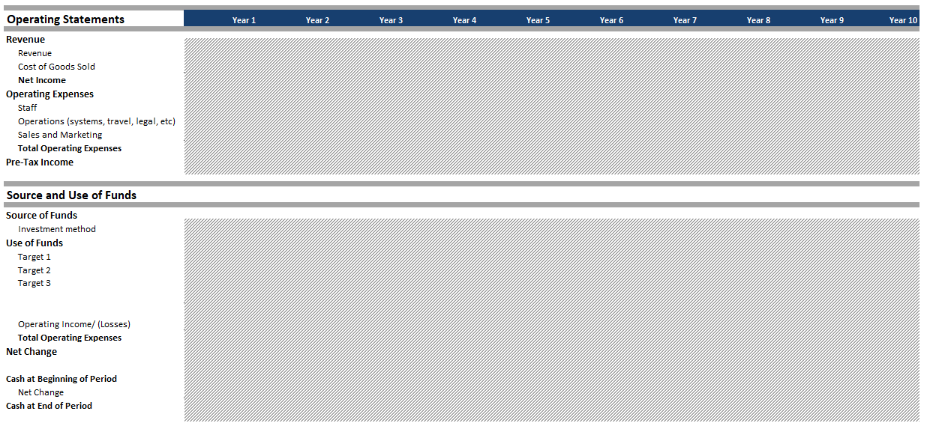

Appendix B: Optional
Any other appendices are optional. You may want to include things like architectural drawings, patents held, and key contracts. These are just examples and not a finite list. Be careful not to give away super confidential information – it should be just enough to drive interest among investors and give them reassurance regarding any potential/ significant risks.

